Interact with cross-functional teammates.

UX design is a highly collaborative field, where designers typically work in cross-functional teams. Your future teammates might include engineers, UX researchers, program managers, product leads, fellow designers, and others. Working with a diverse group of people across functions helps you learn from their areas of expertise and explore other domains within the field of UX. In this reading, you’ll learn about cross-functional team members you’re likely to work with as a new UX designer.

**Teams that UX designers work with**

Cross-functional teams come in lots of shapes and sizes, depending on the organization you work for and the project you’re working on. In general, though, there are a handful of key team members that you’ll get to work with as a UX designer.



**Engineers**: Engineers translate designs into a functioning experience, like an app or a website. They help UX teams figure out if designs are feasible from a technical standpoint and bring that idea to life. Working closely with engineers and involving them early in the design process is critical to ensure your project is set up for success.



**UX researchers**: UX research is all about understanding what users need and expect from your product. UX researchers use methods like observations, interviews, and surveys to understand users' unique perspectives. Findings from research can inform your design decisions each step of the way. If you work at a startup or small business, there’s a good chance you’ll get to do your own UX research. At larger companies though, you’ll likely work with designated UX researchers who will provide research findings to inform your design work.

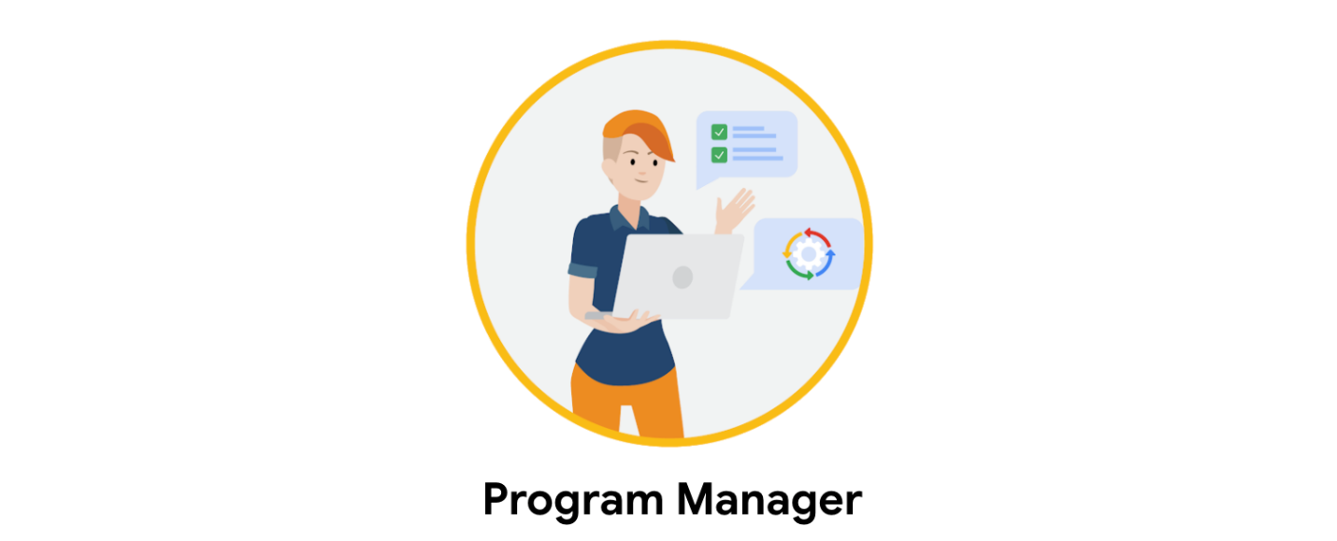

**Program managers:** Program managers ensure clear and timely communication across the team, so that the process of building a useful product moves smoothly from start to finish. Program managers supervise, support, and keep track of the project as a whole. They assign tasks to team members, monitor the project budget, and manage timelines, among other things. Think of your team’s program manager as your go-to source of support when facing any setbacks or issues with your work.



**Product leads:** Product leads are in charge of ensuring the final product’s success and communicating with stakeholders. Your product lead will define the project’s core goals and deliverables, so you can focus on creating innovative design solutions. At some companies, product leads are known as product managers.

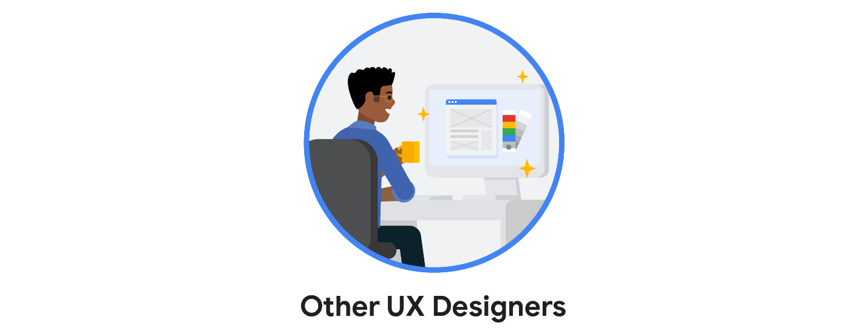

**Other UX designers**: In many cases, you won’t be the sole designer working on a given project, especially if you work at a larger company and when you're a new designer. For example, as an entry-level UX designer, you might collaborate with a more experienced visual designer who can ensure that your designs adhere to the company’s brand standards for things like color and font. Working with other designers is a great chance to learn and ask questions!

**Working together**

Creating a strong product requires working with a cross-functional team of brilliant minds, all contributing their unique skills. As a UX designer, you’ll play a vital role that contributes to the team’s success!